Upwelling signals: a comparison of sea surface temperature products in the Benguela
Amieroh Abrahams^{1,*}, Robert W. Schlegel² , Albertus J. Smit¹
¹Department of Biodiversity and Conservation Biology, University of the Western Cape, Private Bag X17, Bellville 7535, South Africa
²Department of Oceanography, Dalhousie University, Halifax, NS, Canada

Abstract
Global increases in temperature are severely altering land-sea temperature gradients. Bakun (1990) hypothesised that changes within these gradients will directly affect atmospheric pressure cells associated with the development of winds, and will consequently impact upwelling patterns within ecologically important Eastern Boundary Upwelling Systems (EBUS), which often act as ‘buffers’ that protect marine communities from the effects of ocean warming. In this study I used NOAA Optimally Interpolated sea surface temperature (SST) and ERA 5 reanalysis wind products to calculate an upwelling index which was used to detect, identify and quantify upwelling signals that have occurred throughout these EBUS over time last 37 years during summer months. Overall SST increased at three of the four EBUS currents, but there was a decrease in the number of signals detected and no significant increase in the intensity of these signals. The Humboldt current system in particular showed opposite trends with a decrease in SST and increase in the number of upwelling signals detected. Overall, these findings do not agree with the Bakun hypothesis.
Keywords: Climate change, Upwelling, Seawater temperature, coastal regions, Code: R

1.1. Introduction
Coastal upwelling is a major oceanographic process driven by prominent currents within Eastern Boundary Upwelling Systems (EBUS) (Bakun and Nelson, 1991; Messié et al., 2009; Gruber et al., 2011; Pegliasco et al., 2015; Brady et al., 2019). EBUS include the California (CCS), Humboldt (HCS), Canary (CnCS) and Benguela (BCS) current systems (Figure 1), with each of these significantly impacting their associated coastal ecosystems. These systems are characterised as vast regions of coastal ocean occurring along the western shores of continents bordering the Pacific and Atlantic Oceans (Bakun, 1990; Pauly and Christensen, 1995; Bakun et al., 2010; Bakun et al., 2015). EBUS span a wide range of latitudes and are therefore spatially heterogeneous environments. The CCS experiences significant natural variability from sources such as El Niño-Southern Oscillation (ENSO) and the Pacific Decadal Oscillation (PDO) with important ecosystem consequences. The HCS environmental and biological diversity are also heavily influenced by ENSO. The CnCS is heavily influenced by the North Atlantic Oscillation (NAO). The BCS is unique as it experiences interannual variability in the physical and biological conditions related to Benguela Niños and the Pacific ENSO, and in the south, the BCS is largely influenced by the variability in the Agulhas Current (García-Reyes et al., 2015).
EBUS systems are a common source for oceanographic and biological research because the complex interplay of biotic and abiotic processes within EBUS areas results in them being highly productive, diverse, and abundant in marine life. EBUS regions provide up to 20% of the world’s fishery output despite only covering <1% of global ocean area (Bakun 2010, Bakun et al., 2015). The biological productivity in EBUS is mainly as a result of warm-season upwelling (Borges et al., 2003; Carr and Kearns, 2003; Chavez and Messié, 2009; Rossi et al., 2009; García-Reyes et al., 2010) which results from large-scale atmospheric pressure systems that favour along-shore, equatorial winds, in combination with the Coriolis effect that advects surface water offshore (Huyer, 1983; García-Reyes et al., 2015). These regions provide both lucrative economic as well as significant recreational services to 10s of millions of people living along these coastlines and indirectly to the rest of the world. However, recent studies have shown ecological changes in the EBUS ecosystem structure (Fréon et al., 2009; Syndman, et al., 2014; Wang et al., 2015), hence monitoring these systems is becoming increasingly important. EBUS form part of wind-driven ocean circulation, and their existence is entirely dependent on wind direction and strength (Capet et al., 2004). Recognising that the cross-shore atmospheric pressure gradients lead to alongshore, equatorward winds that drive coastal upwelling, Bakun (1990) hypothesised an increase in upwelling favourable winds over time due to intensification of the continental oceanic pressure gradient as a result of climate change (Bakun, 1990; Sydeman et al 2014; Garcia-Reyes et al., 2015). Understanding, therefore, how these winds will change is of high importance for anticipating how upwelling might respond. For example, weaker upwelling may limit nutrient enrichment and potentially impact primary production (Chhak and Di Lorenzo, 2007; García-Reyes et al., 2015). In contrast, stronger upwelling may increase nutrient input and therefore offshore transport (Bakun et al., 2010, 2015). Other impacts include changes in turbulence as a result of increased wind intensity (Cury and Roy, 1989) and changes in chemical mechanisms like ocean acidification and deoxygenation which may ultimately affect productivity (Gruber, 2011). Conservation of fisheries and resources within EBUS could be improved by understanding how nutrient enrichment and productivity are related to upwelling processes, and how likely they are to change in future climate change scenarios to fisheries yields.
Several recent studies have focused on assessing trends in upwelling favourable winds, with conflicting results being reported. The failure to reach consensus revolves largely around the amplitude of unidirectional wind trends relative to amplitudes of seasonal, interannual, and decadal wind variability and the short duration of time series available relative to decadal variability Some researchers question whether the impacts of differential heating on the pressure gradient force drives intensification of coastal upwelling. Rather, a complementary hypothesis proposes that evidence of an intensifying pressure gradient force is limited to poleward migration of the Hadley Cell (Rykaczewski et al., 2015; Brady et al, 2017; Grise et al., 2019; Grise and Davis, 2020). Further complications preventing the agreement on findings in EBUS largely rely on (a) disparate data sets being examined, (b) inconsistencies in data treatment, including analyses of warm seasons versus annual means, (c) quality and density of the data, and (d) changes in measurement techniques An increase (decrease) in upwelling favourable winds can also amplify (reduce) the effect of coastal warming. Therefore, changes in upwelling favourable winds are likely to play an important role in upwelling-related ecosystem processes. Many of the significant upwelling modifications in EBUS, particularly in the Pacific Ocean, have been attributed to large scale atmospheric processes (Jacox et al., 2015). ENSO is the leading cause of variability in the HCS and CCS (Minobe et al., 1999). Other factors such as the Pacific Decadal Oscillation (PDO), and the North Pacific Gyre Oscillation (NPGO) are linked to the variability in the CCS (Chhak and Di Lorenzo, 2007; Di Lorenzo et al., 2008). The BCS, however, is highly influenced by small scale variability and Benguela Niño (Chavez and Messié et al., 2009). No study, as yet, report shared variability and a consistent response across all EBUS.
In this context, the atmospheric and oceanic mechanics responsible for coastal upwelling are interdependent, and changes in one variable, such as wind speed can have an effect on other variables such as upwelling intensity. The focus of this study is to identify whether or not changes in upwelling-related atmospheric variables exist in these systems. The timing and intensity of coastal upwelling are known to have a critical role in the phenology of key marine ecosystem process such as the recruitment of rocky intertidal organisms (Barth et al., 2007; McGregor et al., 2007). Changes in upwelling characteristics have been shown to cause substantial disturbances in ecosystems at multiple trophic levels. We therefore aim to detect if coupled changes occur in the (a) SST patterns, (b) intensity, duration and frequency of wind blowing in a south easterly direction, and (c) the frequency, mean and cumulative intensity of upwelling signals during summer months over a period of 37 years (Table 1.1). Understanding changes within these systems could allow for predictive management and conservation of fisheries and marine resources.
Table 1.1: The description for the metrics of upwelling signals
Name (unit) | Definition
Duration (days) | Consecutive period of time that temperature exceed the threshold
Count (no. events per year) | Number of upwelling signals per year
Mean intensity (°C) | Mean temperature anomaly during the upwelling signal
Cumulative intensity (°C.days) | Sum of the daily intensity anomalies over the duration of the event

1.2. Methods

1.2.1. Data
To evaluate if there are changes in frequency, mean intensity and cumulative intensity of upwelling signals (Table 1.1), this study made use of the gridded data of the global 0.25° National Oceanic and Atmospheric Administration (NOAA) daily Optimally-Interpolated Sea Surface Temperature (dOISST, v.2) (Reynolds et al., 2007; Banzon et al., 2016). This product is constructed by combining different data collected from satellites, ships and buoys (Reynolds et al., 2007; Banzon et al., 2016). The OISST data product has been collected for more than four decades, hence providing us with a long (> 30 years) time series as defined by Hobday et al. (2016) from which upwelling trends and their rate of change can be calculated. Data products with a higher resolution often do not have a time series length of greater than 30 years. In order to detect variation in upwelling signals among the four EBUS (Figure 1.1) (Bakun, 1990; Bakun et al., 2015), wind speed and direction were also deemed as important variables, along with SST. Wind speed and direction variables were downloaded from the ERA5 climate reanalysis produced by ECMWF, providing daily data on regular latitude-longitude grids at 0.25° × 0.25° resolution.
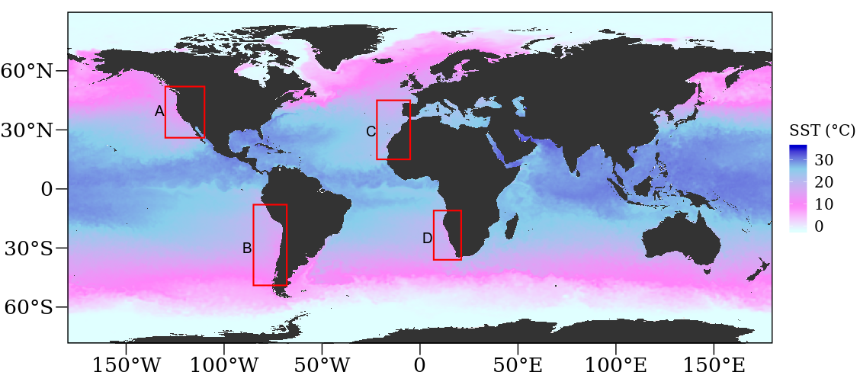

Figure 1.1: OISST throughout the global ocean. The red coloured rectangles delimit EBUS: A: California (CCS), B: Humboldt (HCS), C: Canary (CnCS) and D: Benguela (BCS) current systems.

1.2.2. Upwelling identification
In order to identify whether changes exist in the frequency and intensity of upwelling signals across EBUS it is important to first identify when upwelling occurs. In order to do this, a set of upwelling threshold values needed to be established. The method of determining upwelling signals considers both SST and wind variables which narrows these signals down to a more definite scale. Wind data were used in order to calculate the upwelling index using the formula presented in Fielding and Davis (1989):
upwelling index = μ(cosθ − 160)
The index relies heavily on wind speed and direction in order to identify the presence of upwelling. An upwelling index < 0 represents downwelling whilst an upwelling index > 0 represents upwelling (Fielding and Davis, 1989). An upwelling index > 0 suggests a dropping SST as indicative of active upwelling. This drop in SST coincides with the seasonal SST variation at the 25th percentile threshold. Thus, the combination of SST and upwelling index value was used to identify upwelling. It was then necessary to identify the number of consecutive days that must be exceeded for an upwelling signal to be identified as a discrete event. Here it must be noted that upwelling is known to vary on a seasonal basis and may also occur hourly (sub-daily). Therefore, the minimum duration for the classification of an upwelling signal was set as one day. The rationale behind this is that the OISST dataset is available at a daily resolution. With the upwelling index, temperature and duration thresholds established, the detect_event() function from the heatwaveR package (Schlegel and Smit, 2018) was used to calculate metrics for the upwelling signals. By using this method of identifying signals, we were able to obtain upwelling metrics such as the frequency of occurrence (‘frequency’), ‘mean intensity,’ and ‘cumulative intensity.’ Here, we defined the mean intensity of temperature (°C) represented the highest temperature anomaly value throughout the duration of the signal. Cumulative intensity (°C.days) was defined as the sum of daily intensity anomalies across the duration of each event. Because upwelling signals were calculated relative to seasonal climatologies of percentile exceedances, rather than an absolute definition such as temperatures below a fixed temperature threshold, these signals could occur any time of the year; however, upwelling was shown to be more dominant during summer months, as expected.
With upwelling being influenced by wind patterns, Bakun (1990) predicted that changes in wind patterns would influence the intensity of upwelling signals. As a first step, I observed trends in SST; this was done to simply understand how SST data within these cold-water regions are changing over time. I selected all coastal SST pixels along the latitudinal bands shown for each EBUS in Figure 1.1, as the coastal region is the most favoured to either live permanently, for leisure, recreational activities, or tourism. Given that the OISST time series length is greater than 30 years it is possible to discern the long-term trends within the data. Using a linear regression analyses, I observed if changes exist in the number of times wind blew in south easterly (SE) direction, the duration of SE winds, and intensity of wind blowing in a SE direction with an emphasis on austral (DJF) and boreal (JJA) summer months. The month variable was selected to observe which month expressed the most intense signal. To establish whether differences existed between current and upwelling metrics overtime, I assessed the upwelling metrics as a function year or month. Thereafter, using regression analysis, I compared the average numbers of upwelling signals detected in each of the currents.

1.3. Results
Table 1.2: Linear regressions displaying yearly differences in south-easterly (SE) directed winds and upwelling metrics over a period of 37 years.

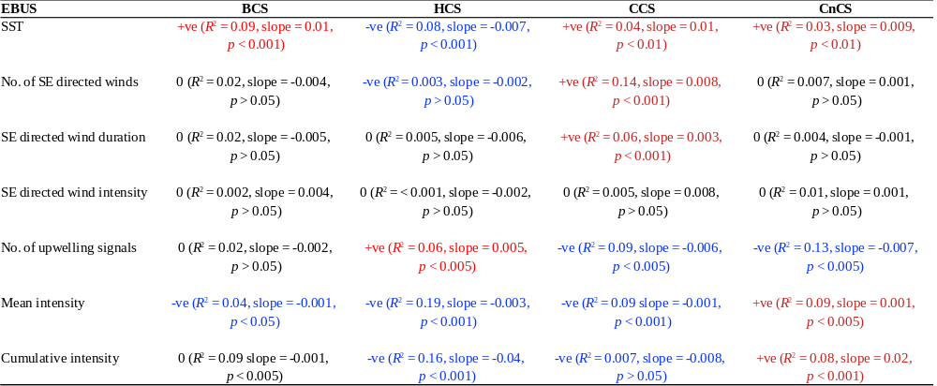
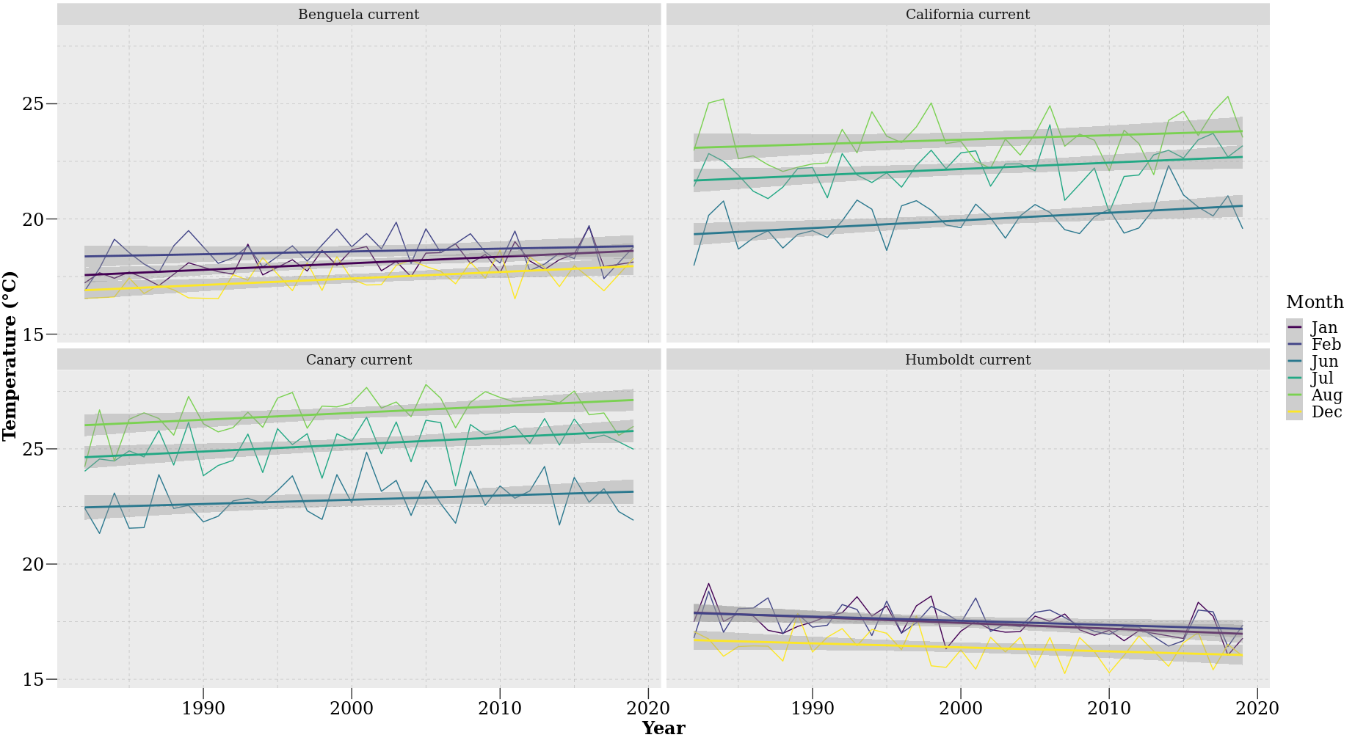

Figure 1.2: SST trends during austral (DJF) and boreal (JJA) summer months over 37 year.
My investigations of upwelling trends within individual time series data for each of the four EBUS currents revealed that changes in SST patterns have occurred at each site over the past 37 years (Figure 1.2). The BCS displayed a slow positive increase in SST of approximately 0.17 ± 0.02 °C.dec⁻¹, with increases being particularly prominent during January of each year. Similarly, the CCS also showed an increase in SST with a positive trend of 0.20 ± 0.02 °C/decade, with its steepest increases occurring during June. The CnCS continually showed warming trends of 0.20 ± 0.01 °C.dec⁻¹, with August representing the month with the steepest increase of 0.20 °C.dec⁻¹. Overall, the SST of the BCS and CnCS currents both increased by approximately 0.21 °C over a period of 37 years. Results obtained from a regression analysis suggested an increase in SST over time with a positive trend in the BCS (R² = 0.09, slope = 0.01 °C.yr⁻¹, p < 0.001), HCS (R² = 0.08, slope = -0.007 °C.yr⁻¹, p < 0.001), CnCS (R² = 0.03, slope = 0.009 °C.yr⁻¹, p < 0.01) and CCS (R² = 0.04, slope = 0.01 °C.yr⁻¹, p < 0.01). Conversely, the HCS displayed a negative trend that was strongest during January (R² = 0.18, slope = -0.02 °C.yr⁻¹, p < 0.005) and February (R² = 0.11, slope = -0.02 °C.yr⁻¹, p < 0.05) of each year respectively. A prominent positive trend was present in the CCS during June (R² = 0.19, slope = 0.03 °C.yr⁻¹, p < 0.005) and July (R² = 0.13, slope = 0.01 °C.yr⁻¹, p < 0.01). A similar trend was present in the CnCS during July (R² = 0.17, slope = 0.03 °C.yr⁻¹, p < 0.01) and August (R² = 0.17, slope = 0.03 °C.yr⁻¹, p < 0.01).
The trend in count of periods of south-easterly directed winds was not uniform among the four EBUS (Figure 1.3). A linear regression analysis showed no significant trends in the number of wind events detected in the BCS (R² = 0.02, slope = -0.004 count.yr⁻¹, p > 0.05), CnCS (R² = 0.007, slope = 0.001 count.yr⁻¹, p > 0.05) and HCS (R² = 0.003, slope = -0.002 count.yr⁻¹, p > 0.05). However, a positive trend in the count of wind events was found in the CCS (R² = 0.14, slope = 0.008 count.yr⁻¹, p < 0.001) (Table 1.2). This trend is particularly prominent during July (R² = 0.22, slope = 0.03 count.yr⁻¹, p < 0.005) and August (R² = 0.23, slope = 0.02 count.yr⁻¹, p < 0.001).

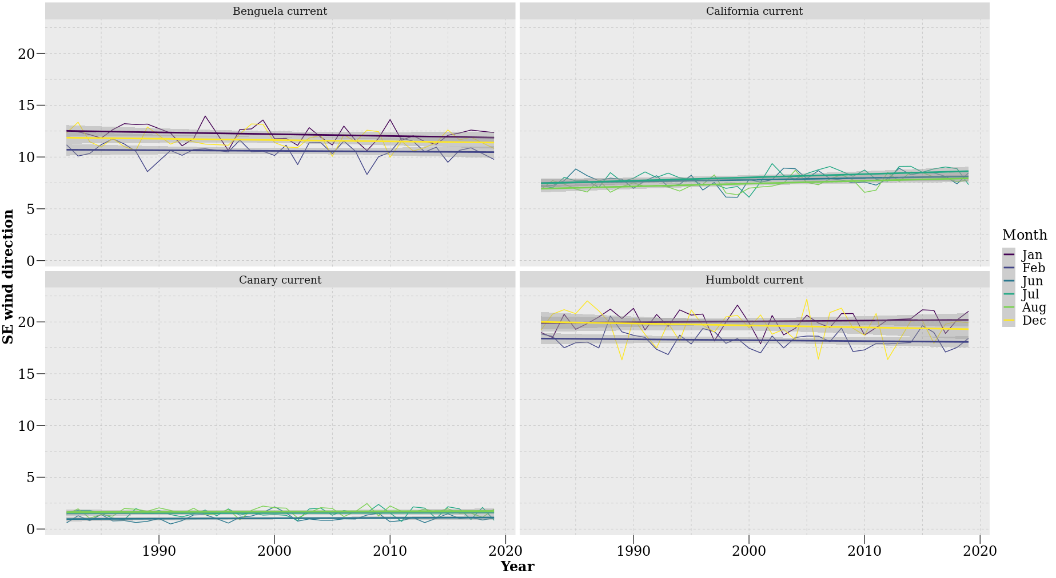

Figure 1.3: Counts of south-easterly directed winds during austral (DJF) and boreal (JJA) summer months over a period of 37 year.
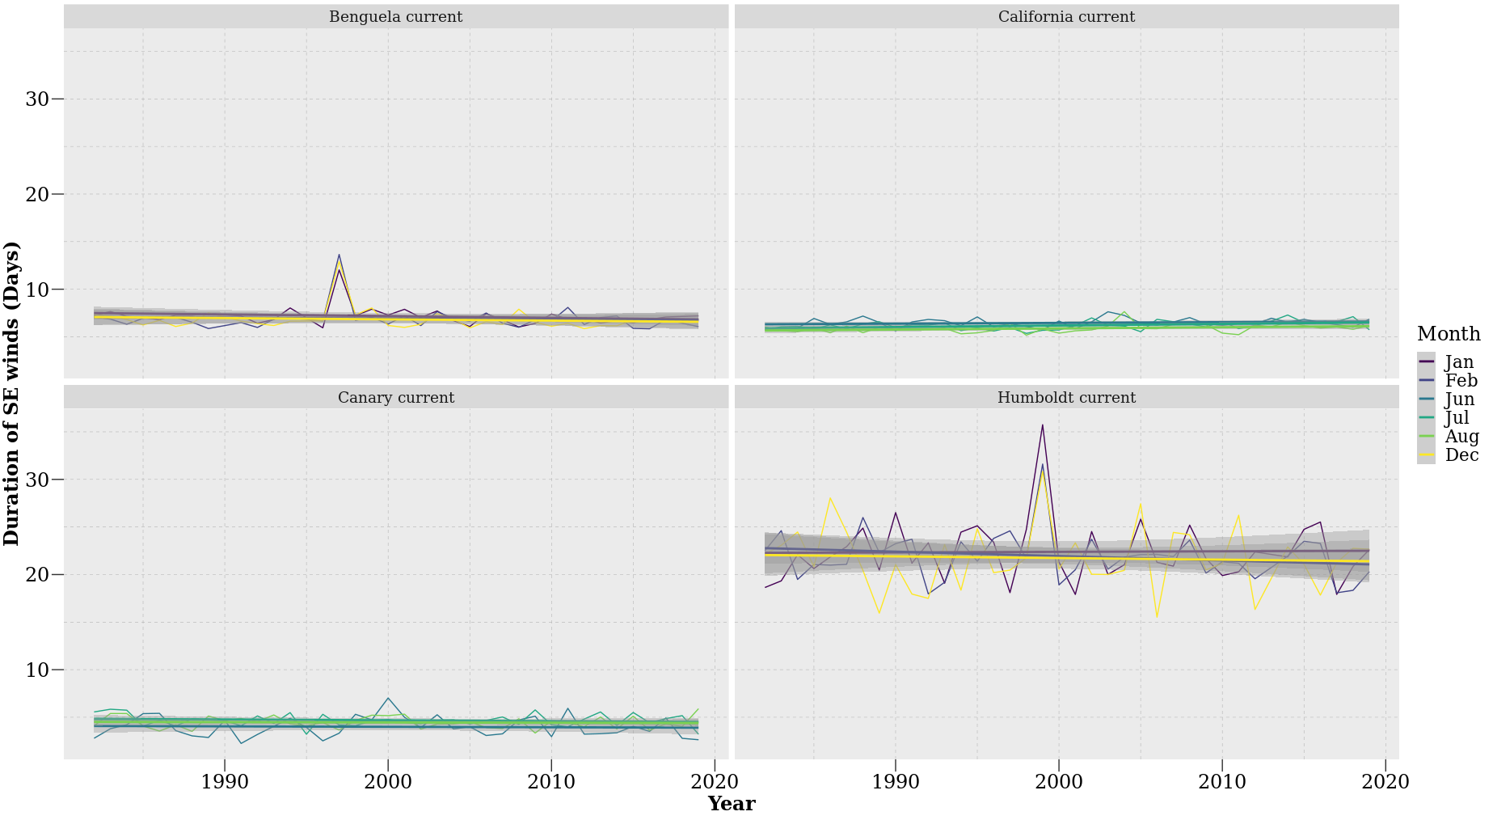

Figure 1.4: Duration of south-easterly directed winds during austral (DJF) and boreal (JJA) summer months over a period of 37 year.
The typical duration of south-easterly directed winds in the BCS, CCS and CnCS appeared to be short, lasting for less than 10 days. Conversely, winds in the HCS often exceeded 20 days (Figure 1.4). Results obtained from a linear regression suggested no change in trend in the duration of south-easterly directed winds in the R² = 0.02, slope = -0.005 days.yr⁻¹, p > 0.05), HCS (R² = 0.005, slope = -0.006 days.yr⁻¹, p > 0.05) and CnCS (R² = 0.004, slope = -0.001 days.yr⁻¹, p > 0.05). The CCS (R² = 0.06, slope = 0.003 days.yr⁻¹, p < 0.001), however, showed a slight increase in the duration of south-easterly directed winds with a positive trend particularly prominent during July (R² = 0.16, slope = 0.02 days.yr⁻¹, p < 0.01; Table 1.2).

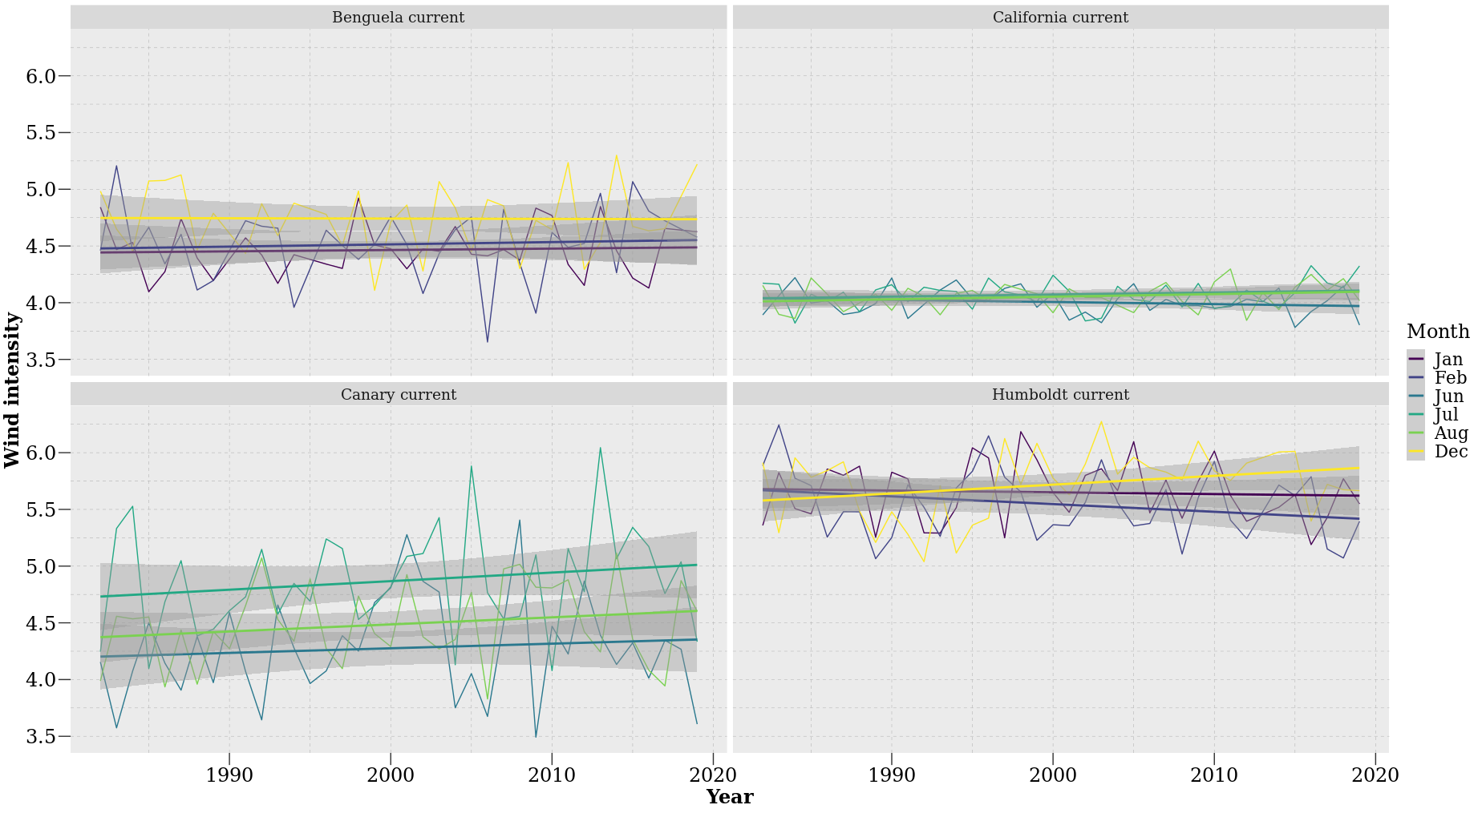

Figure 1 5: The intensity of south-easterly directed winds during austral (DJF) and boreal (JJA) summer months over a period of 37 year.
South-easterly winds were most intense in the HCS (Figure 1.5), where they often exceeded speeds of 5.5 m.s⁻¹. Winds were least intense in the CCS with speeds of approximately 4 m.s⁻¹ being commonplace. There were no changes in trends of wind intensity over time in the BCS (R² = 0.002, slope < 0.0004 m.s⁻¹.yr⁻¹, p > 0.05), HCS (R² = 0.001, slope < -0.001 m.s⁻¹.yr⁻¹, p > 0.05), CnCS (R² = 0.01, slope < 0.002 m.s⁻¹.yr⁻¹, p > 0.05) or CCS (R² = 0.005, slope < 0.005 m.s⁻¹.yr⁻¹, p > 0.05) (Table 1.2).
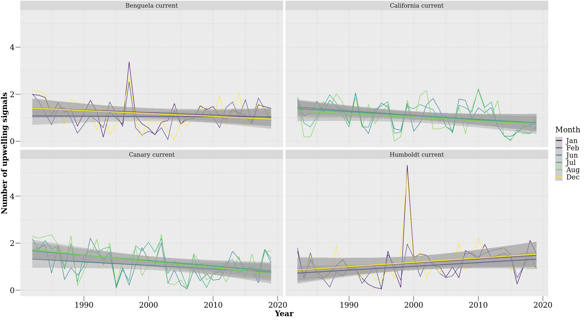

Figure 1.6: Number of upwelling signals detected during austral (DJF) and boreal (JJA) summer months over a period of 37 year.
I found that the number of upwelling signals detected decreased over time in the BCS, CCS and the CnCS, and slightly increased within the HCS current (Figure 3.6). This increase is particularly dominant during December (R² = 0.06, slope = 0.02 count.yr⁻¹, p < 0.005), supporting with decreasing SST temperature values. Results obtained from a regression analysis revealed no change in trend of the BCS (R² = 0.02, slope = -0.002 count.yr⁻¹, p > 0.05) a positive trend in the HCS (R² = 0.06, slope = 0.005 count.yr⁻¹, p < 0.005) which was strongest during Feb (R² = 0.12, slope = 0.02 count.yr⁻¹, p < 0.05). Negative trends in the number of upwelling signals occurred in the CCS (R² = 0.09, slope = -0.006 count.yr⁻¹, p < 0.005) and CnCS (R² = 0.13, slope = -0.007 count.yr⁻¹, p < 0.0001) (Table 1.2).
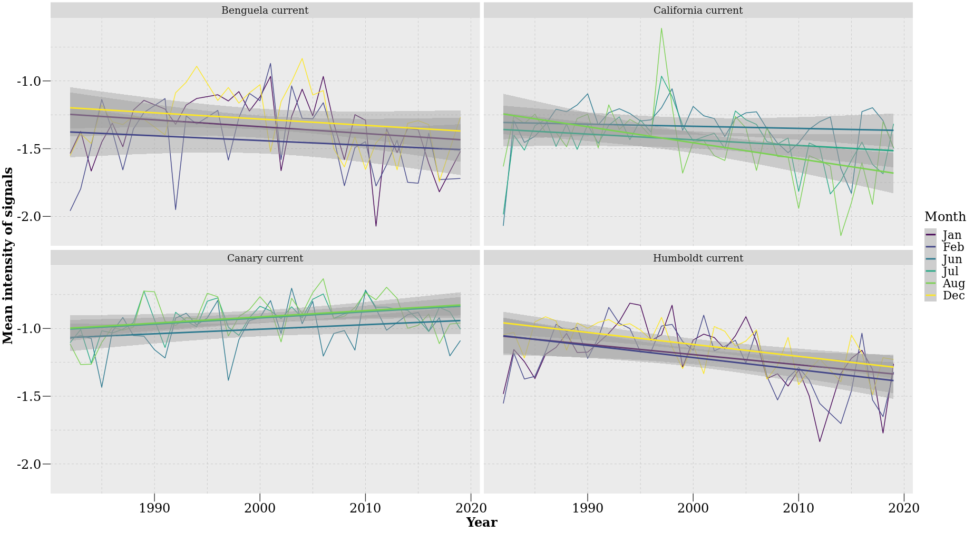

Figure 1.7: Mean intensity of upwelling signals detected during austral (DJF) and boreal (JJA) summer months over a period of 37 year.
The mean intensity of upwelling signals detected decreased over time in the BCS, CCS and the HCS, and slightly increased within the CnCS current (Figure 1.7). A regression analysis further suggested a negative trend which is associated with an increase mean intensity in the BCS (R² = 0.04, slope = -0.001 °C.yr⁻¹, p < 0.05), HCS (R² = 0.19, slope = - 0.003 °C.yr⁻¹, p < 0.001), CCS (R² = 0.09 slope = -0.001 °C.yr⁻¹, p < 0.001). The CnCS (R² = 0.09, slope = 0.001 °C.yr⁻¹, p < 0.005) however express a positive trend which is associated with a decrease in mean intensity (Table 3.2). Similarly, in the HCS a dominant negative trend persists during February (R² = 0.19, slope -0.009 °C.yr⁻¹, p < 0.005) and December (R² = 0.37, slope = -0.008 °C.yr⁻¹, p < 0.001) and during Aug in the CCS (R² = 0.25, slope = 0.01 °C.yr⁻¹, p < 0.001). In the CnCS, a positive trend was present during July (R² = 0.19, slope = 0.004 °C.yr⁻¹, p < 0.001) and August (R² = 0.11, slope = 0.004 °C.yr⁻¹, p < 0.001).
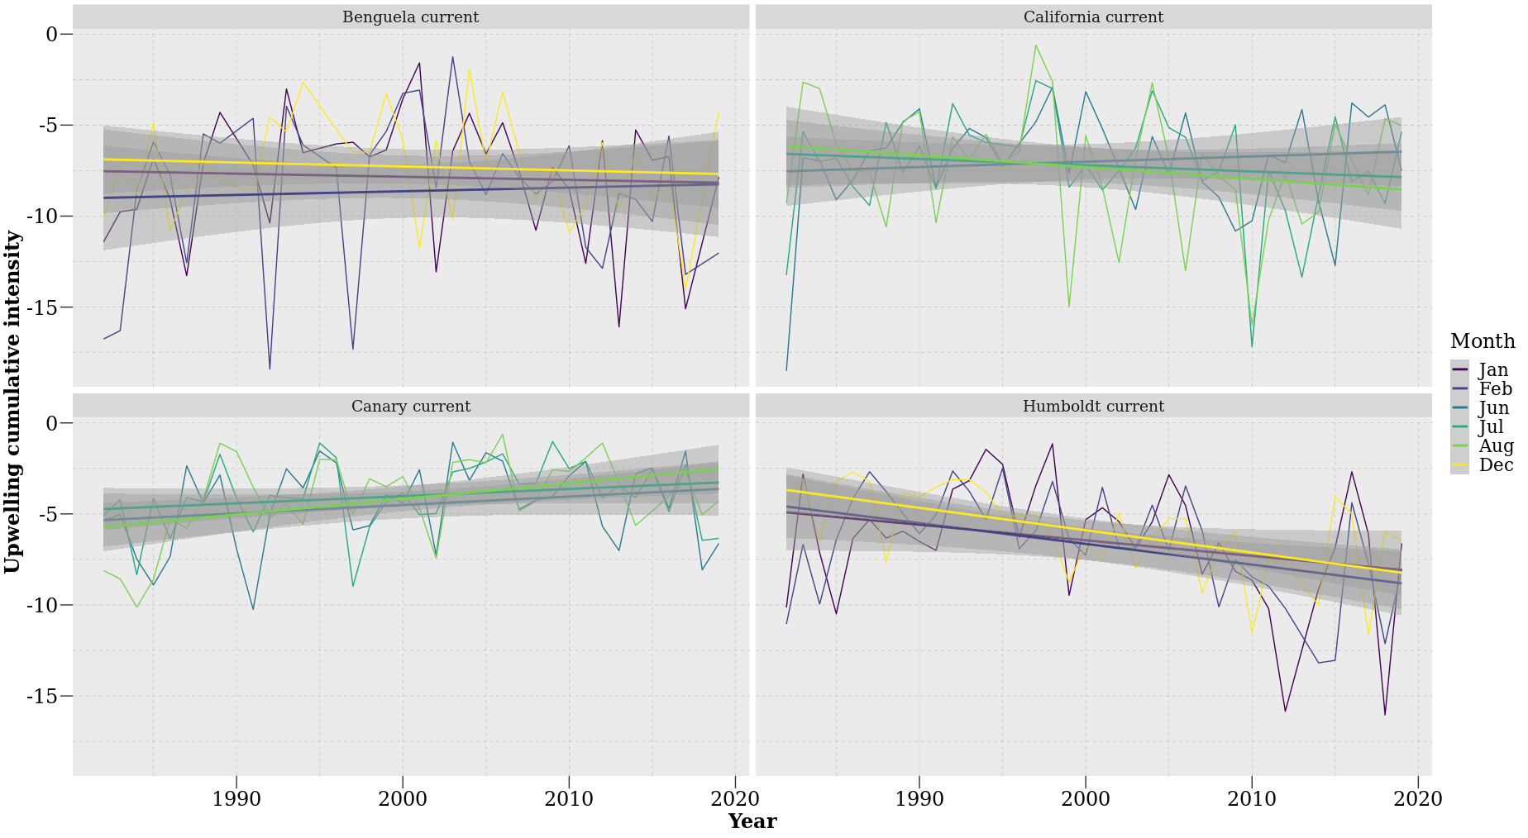

Figure 1.8: Cumulative intensity of upwelling signals detected during austral (DJF) and boreal (JJA) summer months over a period of 37 year.
Figure 1.8 shows a slight decrease in cumulative intensity in the CnCS. The HCS however showed a distinct increase in cumulative intensity over time. The results obtain from a regression analyses further suggest no change in trend occurs within the BCS (R² = 0.001, slope = -0.003 °C.days.yr⁻¹, p > 0.05). However, a negative trend was present in the HCS (R² = 0.16, slope = -0.04 °C.days.yr⁻¹, p < 0.001) and CCS (R² = 0.007, slope = -0.008 °C.days.yr⁻¹, p > 0.05) followed by a slightly positive trend in the CnCS (R² = 0.08, slope = 0.02 °C.days.yr⁻¹, p < 0.001) (Table 1.2). The HCS showed a prominent negative monthly trend during Feb (R² = 0.19, slope = -0.11 °C.days.yr⁻¹, p < 0.005) and Dec (R² = 0.34, slope = -0.12 °C.days.yr⁻¹, p < 0.001). In the CnCS a positive trend persisted during Aug (R² = 0.17, slope = 0.09 °C.days.yr⁻¹, p > 0.05)

1.4. Discussion
Bakun (1990) proposed that an increase in greenhouse gases will result in considerable change in land-sea pressure gradients that will affect global wind patterns and ultimately result in an increase in the intensity of upwelling signals across the world’s oceans. Here, I tested this hypothesis by analysing upwelling trends at four prominent upwelling regions, with an emphasis on austral (DJF) and boreal (JJA) summer months as this is when upwelling is most dominant. My results yielded weak evidence for increases in the intensity of upwelling signals across the southern and northern hemispheres of the world’s coastal upwelling regions. Rather, the mean intensity of upwelling signals decreased in the BCS, HCS and CCS. However, the CnCS showed a slight increase in the mean intensity of upwelling signals over time. Given that upwelling signals did not intensify in all of the EBUS, I further investigated if SST and wind patterns have changed there over time. When observing the SST patterns within EBUS currents it was evident that the average temperature across all EBUS currents is continually increasing, except at the HCS. The same was not true of wind intensity, as I found no significant relationship between increased wind intensity and time at the different EBUS regions. Similarly, I found no difference in the duration and number of wind events blowing in a south easterly direction for the BCS, HCS, CnCS. However, there was a significant increase in the duration of wind events and in number of wind events blowing in a south easterly direction for the CCS. By combining wind and SST products I was able to observe trends in the number of upwelling signals detected. Our results suggested a decrease in the number of upwelling signals detected in three of the EBUS, except for the HCS, which showed an increase in the number of upwelling signals but no associated increase in wind duration/intensity detected over a period of 37 years. It was also particularly interesting to observe no increase in the mean intensity, cumulative intensity and number of upwelling signals detected of the CCS given this current was associated with an increase in the duration and number of south easterly winds. These findings do not agree with the hypothesis proposed by Bakun (1990) as the wind intensity did not intensify overtime and the resultant mean intensity of upwelling signals did not increase.
Given my findings here, it is evident that the effects of anthropogenic changes towards altering patterns of upwelling are more complex than proposed by Bakun (1990). It demonstrates the need to consider changes in both thermal and in-shore hydrodynamic (turbulence through breaking waves, tidal mixing and wind driven currents) processes when interpreting the full dynamical response (e.g. in conditions of changing wind magnitude and direction) of the coupled atmospheric-ocean system to climate warming. In this regard, our conclusion differs in respect to recent studies (e.g. Wang et al., 2015) that have examined the relationship between increasing summertime land-sea temperature differences and intensified upwelling in response to climate change. Rykaczewski et al. (2015) suggested that increased land-sea temperature differences are ubiquitous into projections of future conditions, but that summertime upwelling is limited to the polar extremes of upwelling zones. If true, this would indicate that increased land-sea temperature differences do not have a dominant influence on upwelling intensity. Additionally, changes in upwelling favourable winds are not always directly related to broad increases in land-sea temperature differences associated with climate change (Rykaczewski et al., 2015). Instead, the intensity of upwelling-favourable winds could be related to shifts in seasonal development and geographic positioning of the four major atmospheric high-pressure systems that are completely unrelated to anthropogenic influences. Research suggest that changes in sea level pressure (SLP) fields are expected in response to increased greenhouse gas concentration (Gillett et al., 2013); these shifts will initiate changes in the magnitude, location and timing of upwelling favourable winds that are more consequential than increase land-sea temperature differences.
The results obtained in this study do not support the hypothesis that intensified upwelling will result from the increased land-sea difference associated with global warming. Additionally, given the short time series it is highly likely that a natural climatic variable impacted the trends discussed. For example, the occurrence of ENSO at the end of the time series could also have initiated an anomalously warm SST in EBUS and potentially affect the trends observed. Further investigation is required to fully explain the observed trends of upwelling within EBUS regions. Such investigations should ideally directly focus on the impact of inter-annual variability within individual EBUS currents. My results also lead to speculation about the potential connection between ENSO within EBUS (Peterson and Schwing, 2003; Blamey et al., 2012; Sydeman et al., 2013). ENSO represents a weakening of the Walker cell circulation (Wang, 2004). During normal Walker cell conditions there is consistent upwelling, and this upwelling contributes to cool SST (Bakun, 2010). Since the CnCS data show an increase in SST, it may also be concluded that there has been a weakening or reversal of the trade winds and a resultant El Niño is occurring (Vallis 1986; Saji et al., 1999). ENSO sends out atmospheric and oceanic Rossby waves that can have an effect on climate processes (Battisti, 1989; Holbrook et al., 2011). The effects ENSO has on its counterpart La Niña produces teleconnection that alter average climatic states (Diaz et al., 2001; Fogt and Bromwich, 2006; Yeh et al., 2018). As a result, it can also be assumed that the weakening of HCS is potentially represented as a consequence of the effects by La Niña. During La Niña, the Walker cell circulation is enhanced (Sohn et al., 2013), meaning that pre-existing trade winds and SST strengthen. The low SSTs created by the presence of La Niña is accompanied by anticyclones. The anticyclones rotate counter-clockwise in the southern hemisphere and therefore its winds travel equatorward where they deflect surface water away from the shore, resulting in a net Ekman veering that encourages coastal upwelling and lowers SSTs. The HCS possessed the strongest winds when compared to the other EBUS. These winds consist of dry air creating climatic conditions that encourage evaporation. Evaporation requires heat, and this heat is supplied by the sea surface. Since evaporation takes heat away from the sea surface it has an overall cooling effect. For the CnCS, the enhanced evaporation caused by the strong offshore winds result in a cooling of the current system’s SSTs. This upwelling system is typically characterised by generating a climate with low cloud coverage. Low cloud coverage allows for a high amount of solar radiation to be received at the ocean’s surface.
There is low confidence regarding the effects of climate change on coastal temperatures and biogeochemistry in the EBUS. However, consideration is now given to shifts in the intensity and latitudinal location of upwelling and will be essential for identifying portions of the coast more at risk of ocean acidification, increased hypoxia, and eutrophication under conditions of future warming (Rykaczewski et al., 2015). This is primarily due to the complex global and local processes affecting these patterns, but also largely due to the resolution and data availability combined with the large degree of decadal variability in temperatures and biogeochemical properties. Most of the remotely sensed SST and wind products do not have sufficient resolution to accurately detect nuances within the upwelling process. Nevertheless, these data sources show promise in correcting bias by including higher-resolution products which consider land-and ocean-air interactions, cloud formation, and oceanic mesoscale processes. Furthermore, changes in local, alongshore winds are among one of several processes necessary to consider when exploring the sensitivity of upwelling in relation to climate change (Bakun et al., 2015). Waters supplied to upwelling systems, including nutrient concentrations, as well as the characteristics of the ocean carbonate system, and dissolved oxygen levels are sensitive to climate change (Rykaczewski and Dunne, 2010) and have important ecological impacts (Lu et al., 2010).
In conclusion, my findings reject the hypothesis proposed by Bakun (1990). Wind events blowing in a south easterly direction did not increase or intensify over time, and importantly a negative trend exists in three of the four EBUS with the CnCS being the only current to display a slight increase in the mean and cumulative intensity of coastal upwelling signals. Therefore, there is an urgent need to carefully consider both geostrophic and ageostrophic processes affecting the boundary layer of the coastal ocean as these analyses may provide insight to the dynamics regulating changes in the upwelling. Additionally, changes in water-column stratiﬁcation can alter upwelling efﬁcacy (Roemmich and McGowan, 1995; Chhak and Di Lorenzo, 2007), and the offshore distribution of maximal upwelling (in addition to associated changes in wind-stress curl) can inﬂuence the rate and spatial location of upwelling (Rykaczewski et al., 2015; Jacox et al., 2015). Interactions among basin-scale processes and subsurface biogeochemistry that alter source-water properties of upwelled water masses, stratiﬁcation, and mesoscale hydrographic features should be considered in concert with atmospheric forcing to develop a comprehensive understanding of the implications of climate change for the world’s upwelling ecosystems. However, given the natural variability of EBUS, they are proven to be more resilient to climate change when compared to other ecosystems. The lack of expectations for EBUS ecosystems is of concern because these regions are biologically rich and as a result are highly relevant to society with regards to economics, conservation and biodiversity. Furthermore, I propose that the focus of this implementation be on nearshore ecosystems as these are more important to human livelihoods as well as being at greater risk when compared to other marine organisms.

References
Bakun, A., 1990. Global climate change and intensification of coastal ocean upwelling. Science, 247(4939), pp.198-201.
Bakun, A., Nelson, C.S., 1991. The seasonal cycle of wind-stress curl in subtropical eastern boundary current regions. Journal of Physical Oceanography, 21(12), pp.1815-1834.
Bakun, A., Field, D.B., Redondo‐Rodriguez, A.N.A., Weeks, S.J., 2010. Greenhouse gas, upwelling‐favorable winds, and the future of coastal ocean upwelling ecosystems. Global Change Biology, 16(4), pp.1213-1228.
Bakun, A., Black, B.A., Bograd, S.J., Garcia-Reyes, M., Miller, A.J., Rykaczewski, R.R. and Sydeman, W.J., 2015. Anticipated effects of climate change on coastal upwelling ecosystems. Current Climate Change Reports, 1(2), pp.85-93.
Banzon, V., Smith, T.M., Chin, T.M., Liu, C.Y. and Hankins, W., 2016. A long-term record of blended satellite and in situ sea-surface temperature for climate monitoring, modeling and environmental studies.
Barth, J.A., Menge, B.A., Lubchenco, J., Chan, F., Bane, J.M., Kirincich, A.R., McManus, M.A., Nielsen, K.J., Pierce, S.D. and Washburn, L., 2007. Delayed upwelling alters nearshore coastal ocean ecosystems in the northern California current. Proceedings of the National Academy of Sciences, 104(10), pp.3719-3724.
Battisti, D.S., 1989. On the role of off-equatorial oceanic Rossby waves during ENSO. Journal of physical Oceanography, 19(4), pp.551-560.
Blamey, L.K., Howard, J.A., Agenbag, J., Jarre, A., 2012. Regime-shifts in the southern Benguela shelf and inshore region. Progress in Oceanography, 106, pp.80-95.
Borges, M.F., Santos, A.M.P., Crato, N., Mendes, H., Mota, B., 2003. Sardine regime shifts off Portugal: a time series analysis of catches and wind conditions. Scientia Marina, 67(S1), pp.235-244.
Brady, R.X., Alexander, M.A., Lovenduski, N.S., Rykaczewski, R.R., 2017. Emergent anthropogenic trends in California Current upwelling. Geophysical Research Letters, 44(10), pp.5044-5052.
Brady, R.X., Lovenduski, N.S., Alexander, M.A., Jacox, M. and Gruber, N., 2019. On the role of climate modes in modulating the air–sea CO2 fluxes in eastern boundary upwelling systems. Biogeosciences, 16(2), pp.329-346.
Capet, X.J., Marchesiello, P., McWilliams, J.C., 2004. Upwelling response to coastal wind profiles. Geophysical Research Letters, 31(13).
Carr, M.E., 2001. Estimation of potential productivity in Eastern Boundary Currents using remote sensing. Deep Sea Research Part II: Topical Studies in Oceanography, 49(1-3), pp.59-80.
Chavez, F.P., Messié, M., 2009. A comparison of eastern boundary upwelling ecosystems. Progress in Oceanography, 83(1-4), pp.80-96.
Chhak, K., Di Lorenzo, E., 2007. Decadal variations in the California Current upwelling cells. Geophysical Research Letters, 34(14).
Cury, P. and Roy, C., 1989. Optimal environmental window and pelagic fish recruitment success in upwelling areas. Canadian Journal of Fisheries and Aquatic Sciences, 46(4), pp.670-680.
Diaz, H.F., Hoerling, M.P. and Eischeid, J.K., 2001. ENSO variability, teleconnections and climate change. International Journal of Climatology: A Journal of the Royal Meteorological Society, 21(15), pp.1845-1862.
Di Lorenzo, E., Schneider, N., Cobb, K.M., Franks, P.J.S., Chhak, K., Miller, A.J., McWilliams, J.C., Bograd, S.J., Arango, H., Curchitser, E., Powell, T.M., 2008. North Pacific Gyre Oscillation links ocean climate and ecosystem change. Geophysical Research Letters, 35(8).
Fielding, P. J., Davis, C. L., 1989. Carbon and nitrogen resources available to kelp bed filter feeders in an upwelling environment. Marine Ecology Progress Series, pp.181-189.
Fogt, R.L. and Bromwich, D.H., 2006. Decadal variability of the ENSO teleconnection to the high-latitude South Pacific governed by coupling with the southern annular mode. Journal of Climate, 19(6), pp.979-997.
Fréon, P., Arístegui, J., Bertrand, A., Crawford, R.J., Field, J.C., Gibbons, M.J., Tam, J., Hutchings, L., Masski, H., Mullon, C., Ramdani, M., 2009. Functional group biodiversity in Eastern Boundary Upwelling Ecosystems questions the wasp-waist trophic structure. Progress in Oceanography, 83(1-4), pp.97-106.
García‐Reyes, M., Largier, J., 2010. Observations of increased wind‐driven coastal upwelling off central California. Journal of Geophysical Research: Oceans, 115(C4).
García-Reyes, M., Sydeman, W.J., Schoeman, D.S., Rykaczewski, R.R., Black, B.A., Smit, A.J., Bograd, S.J., 2015. Under pressure: climate change, upwelling, and eastern boundary upwelling ecosystems. Frontiers in Marine Science, 2, p.109.
Gillett, N.P., Fyfe, J.C., Parker, D.E., 2013. Attribution of observed sea level pressure trends to greenhouse gas, aerosol, and ozone changes. Geophysical Research Letters, 40(10), pp.2302-2306.
Grise, K.M., Davis, S.M., Simpson, I.R., Waugh, D.W., Fu, Q., Allen, R.J., Rosenlof, K.H., Ummenhofer, C.C., Karnauskas, K.B., Maycock, A.C. and Quan, X.W., 2019. Recent tropical expansion: Natural variability or forced response?. Journal of Climate, 32(5), pp.1551-1571.
Grise, K.M. and Davis, S.M., 2020. Hadley cell expansion in CMIP6 models. Atmospheric Chemistry & Physics, 20(9).
Gruber, N., Lachkar, Z., Frenzel, H., Marchesiello, P., Münnich, M., McWilliams, J.C., Nagai, T., Plattner, G.K., 2011. Eddy-induced reduction of biological production in eastern boundary upwelling systems. Nature geoscience, 4(11), pp.787-792.
Hobday, A.J., Oliver, E.C., Gupta, A.S., Benthuysen, J.A., Burrows, M.T., Donat, M.G., Holbrook, N.J., Moore, P.J., Thomsen, M.S., Wernberg, T. and Smale, D.A., 2018. Categorizing and naming marine heatwaves. Oceanography, 31(2), pp.162-173.
Holbrook, N.J., Goodwin, I.D., McGregor, S., Molina, E. and Power, S.B., 2011. ENSO to multi-decadal time scale changes in East Australian Current transports and Fort Denison sea level: Oceanic Rossby waves as the connecting mechanism. Deep Sea Research Part II: Topical Studies in Oceanography, 58(5), pp.547-558.
Huyer, A., 1983. Coastal upwelling in the California Current system. Progress in oceanography, 12(3), pp.259-284.
Jacox, M.G., Fiechter, J., Moore, A.M., Edwards, C.A., 2015. ENSO and the C alifornia C urrent coastal upwelling response. Journal of Geophysical Research: Oceans, 120(3), pp.1691-1702.
Lu, F., Hu, H., Sun, W., Zhu, J., Liu, G., Zhou, W., Zhang, Q., Shi, P., Liu, X., Wu, X., Zhang, L., 2018. Effects of national ecological restoration projects on carbon sequestration in China from 2001 to 2010. Proceedings of the National Academy of Sciences, 115(16), pp.4039-4044.
McGregor, H.V., Dima, M., Fischer, H.W. and Mulitza, S., 2007. Rapid 20th-century increase in coastal upwelling off northwest Africa. science, 315(5812), pp.637-639.
Messié, M., Ledesma, J., Kolber, D.D., Michisaki, R.P., Foley, D.G., Chavez, F.P., 2009. Potential new production estimates in four eastern boundary upwelling ecosystems. Progress in Oceanography, 83(1-4), pp.151-158
Minobe, S., 1999. Resonance in bidecadal and pentadecadal climate oscillations over the North Pacific: Role in climatic regime shifts. Geophysical Research Letters, 26(7), pp.855-858.
Pauly, D., Christensen, V., 1995. Primary production required to sustain global fisheries. Nature, 374(6519), pp.255-257.
Pegliasco, C., Chaigneau, A., Morrow, R., 2015. Main eddy vertical structures observed in the four major Eastern Boundary Upwelling Systems. Journal of Geophysical Research: Oceans, 120(9), pp.6008-6033.
Peterson, W.T., Schwing, F.B., 2003. A new climate regime in northeast Pacific ecosystems. Geophysical research letters, 30(17).
Reynolds, R.W., Chelton, D.B., 2010. Comparisons of daily sea surface temperature analyses for 2007–08. Journal of climate, 23(13), pp.3545-3562.
Roemmich, D., McGowan, J., 1995. Climatic warming and the decline of zooplankton in the California Current. Science, 267(5202), pp.1324-1326.
Rykaczewski, R.R. and Dunne, J.P., 2010. Enhanced nutrient supply to the California Current Ecosystem with global warming and increased stratification in an earth system model. Geophysical Research Letters, 37(21).
Rykaczewski, R.R., Dunne, J.P., Sydeman, W.J., García‐Reyes, M., Black, B.A., Bograd, S.J., 2015. Poleward displacement of coastal upwelling‐favorable winds in the ocean's eastern boundary currents through the 21st century. Geophysical Research Letters, 42(15), pp.6424-6431.
Saji, N.H., Goswami, B.N., Vinayachandran, P.N. and Yamagata, T., 1999. A dipole mode in the tropical Indian Ocean. Nature, 401(6751), pp.360-363.
Schlegel, R.W., Smit, A.J., 2018. heatwaveR: a central algorithm for the detection of heatwaves and cold-spells. Journal of Open Source Software, 3(27), p.821.
Sohn, B.J., Yeh, S.W., Schmetz, J. and Song, H.J., 2013. Observational evidences of Walker circulation change over the last 30 years contrasting with GCM results. Climate Dynamics, 40(7-8), pp.1721-1732.
Sydeman, W.J., García-Reyes, M., Schoeman, D.S., Rykaczewski, R.R., Thompson, S.A., Black, B.A., Bograd, S.J., 2014. Climate change and wind intensification in coastal upwelling ecosystems. Science, 345(6192), pp.77-80.
Vallis, G.K., 1986. El Niño: A chaotic dynamical system?. Science, 232(4747), pp.243-245.
Wang, C., 2004. ENSO, Atlantic climate variability, and the Walker and Hadley circulations. In The Hadley circulation: Present, past and future (pp. 173-202). Springer, Dordrecht.
Wang, X.L., Cai, X.D., Su, Z.E., Chen, M.C., Wu, D., Li, L., Liu, N.L., Lu, C.Y., Pan, J.W., 2015. Quantum teleportation of multiple degrees of freedom of a single photon. Nature, 518(7540), pp.516-519.
Yeh, S.W., Cai, W., Min, S.K., McPhaden, M.J., Dommenget, D., Dewitte, B., Collins, M., Ashok, K., An, S.I., Yim, B.Y. and Kug, J.S., 2018. ENSO atmospheric teleconnections and their response to greenhouse gas forcing. Reviews of Geophysics, 56(1), pp.185-206.

